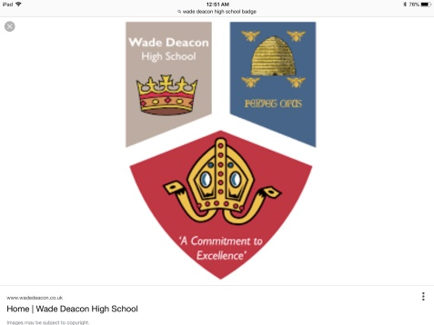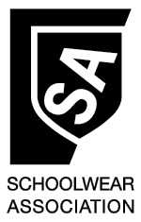

**LASER SCHOOLWEAR**

**WADE DEACON HIGH SCHOOL**

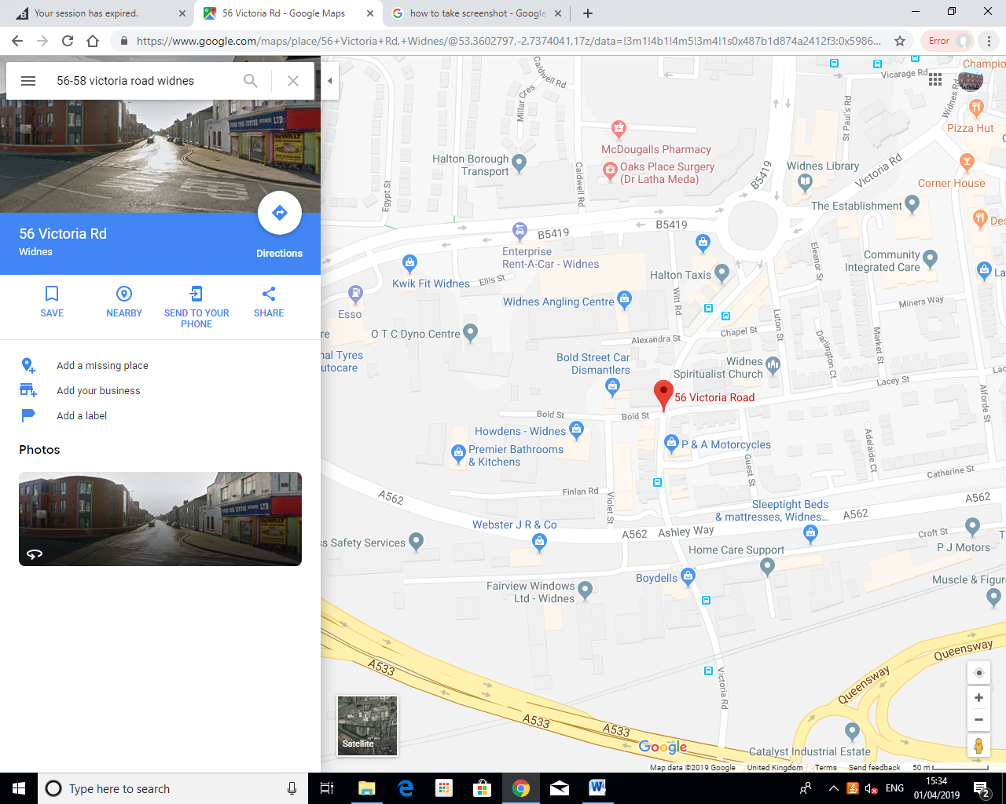

56-58 VICTORIA ROAD

WIDNES WA8 7RJ

0151 345 4867

**Uniform List**

Blazer (Black/Blue)

Pullover (Black)

Shirt/Blouse (White)

Trousers (Black)

Skirt (Tartan)

Tie

**Sportswear List**

Boys Polo Top (Black/Red)

Girls P.E Top (Black/Red)

Shorts (Black)

Socks (Black/Red)

**Price**

From £33.00

From £15.00

From £12.00

From £12.00

From £20.00

£6.00

From £16.00

From £14.00

From £12.00

£6.00

**Uniform List**

Sweatshirt – From £10

Sweatcardigan – From £12

Polo – From £7

Satchel – From £7

Book Bag – From £5

Hat – From £5

**OPENING HOURS**

**Monday** – 9:30 am to 5:00 pm

**Tuesday** – 9:30 am to 5:00 pm

**Wednesday** – 9:30 am to 5:00 pm

**Thursday** – 9:30 am to 5:00 pm

**Friday** – 9:30 am to 5:00 pm

**Saturday** – 9:30 am to 5:00 pm

OPEN ON SUNDAYS THROUGHOUT AUGUST

**NOW ALSO AVAILABLE TO PURCHASE ONLINE AT WWW.LASERSCHOOLWEAR.NET**